TASK 31 :DECLARATIVE PIPELINE FOR BUILDING, TESTING, PACKAGING A COMPLEX JAVA APPLICATION • Activity: • Create a declarative pipeline to build, test and package a spring pet clinic application • Steps: • Create a pipeline project DeclarativePetClinic Code is available in Jenkinsfile of https://github.com/AnjuMeleth/spring-petclinic.git • Definition of Done: • Upload the screenshot of Jenkins dashboard of the project to the GitHub under the folder Task31

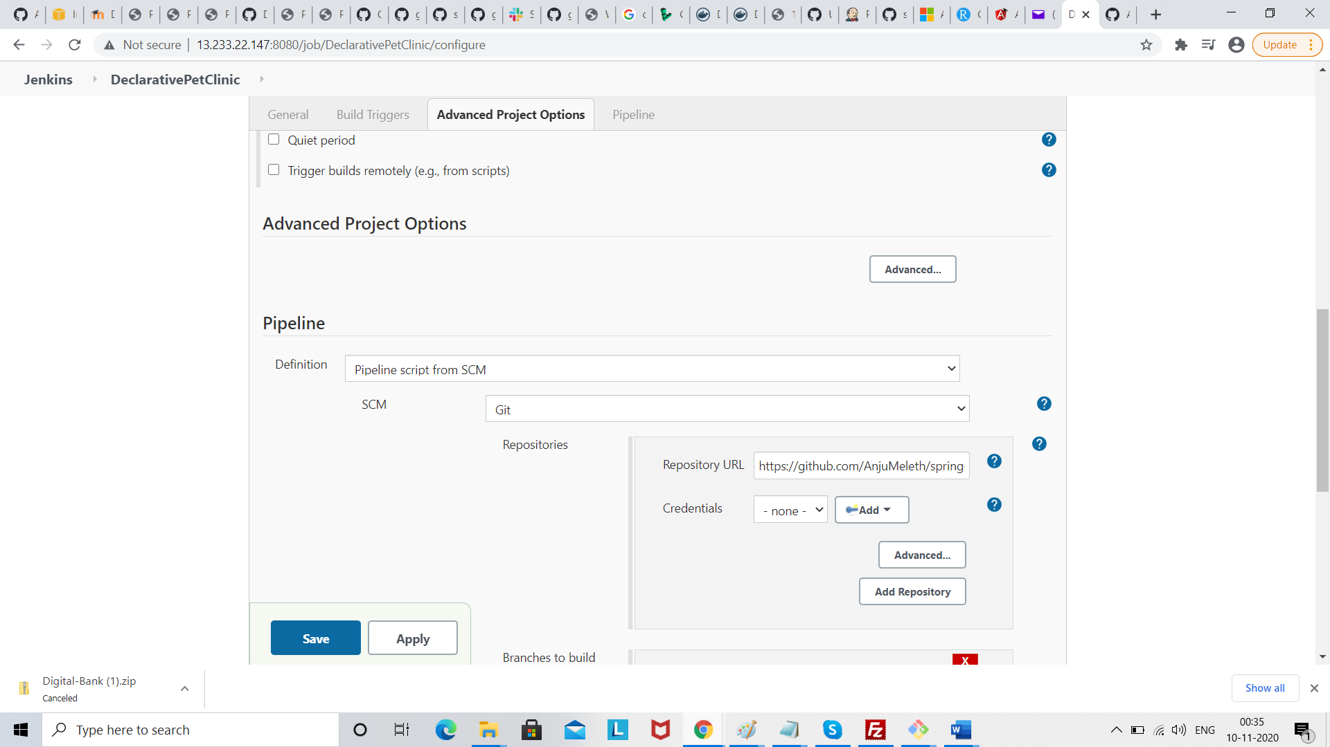

Click save

Click build

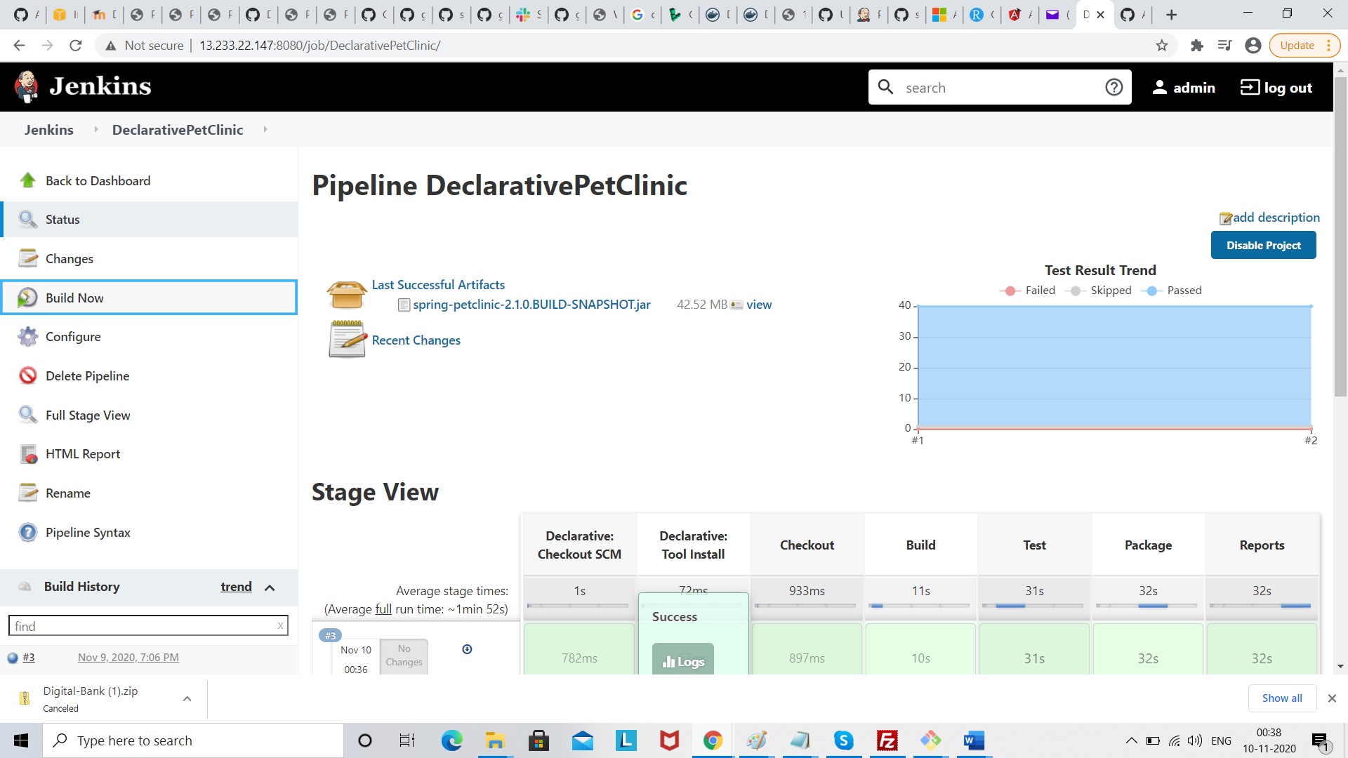

Console output

